Lab name：**NE555 Timer IC** Student ID： B11102112 Name: Chiajui Lee

# Purpose

The NE555 timer IC is a versatile integrated circuit widely used in analog and digital applications, particularly for timing, pulse generation, and oscillation. Through practical experiments, we learn to configure it in three fundamental modes - monostable (for single-pulse timing), bistable (as a basic flip-flop switch), and astable (as a square wave oscillator) - to generate signals with precise frequency and pulse-width control, making it essential for applications ranging from timer circuits and switch debouncing to PWM systems and frequency modulation in both electronics education and practical design.

# Steps

1. Construct the specified circuit using the NE555 timer IC, capacitors, and resistors as required by the problem statement.
2. Connect the power supply to provide +9V to pin 8 (𝑉CC ) of the NE555 timer IC.
3. Measure the output results using an oscilloscope.

# Data

## Monostable Circuit

1. Output Square-wave

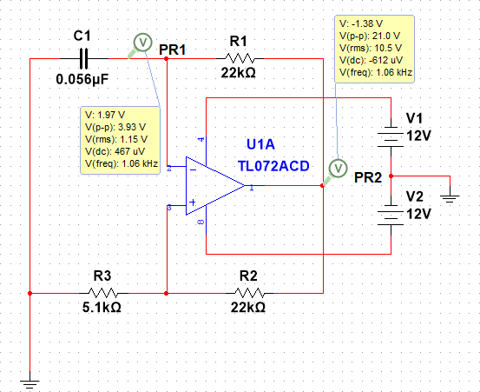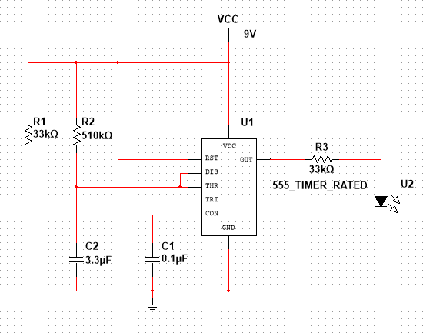

1. Output waveform

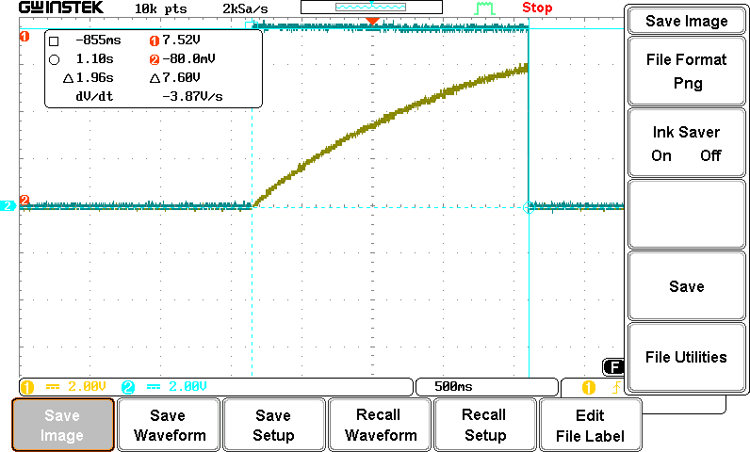

1. Measured value

|  |  |  |
| --- | --- | --- |
|  | Measured Value | Theoretical Value |
| Capacitance Voltage | 5.96V |  |
| Output Voltage | 7.6V |  |
| Pulse width | 1.96s | 1.815s |

## Astable Circuit

* 1. 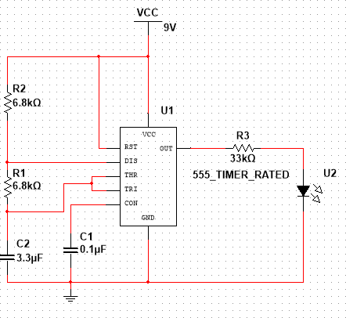Output Triangle-wave
  2. Output waveform

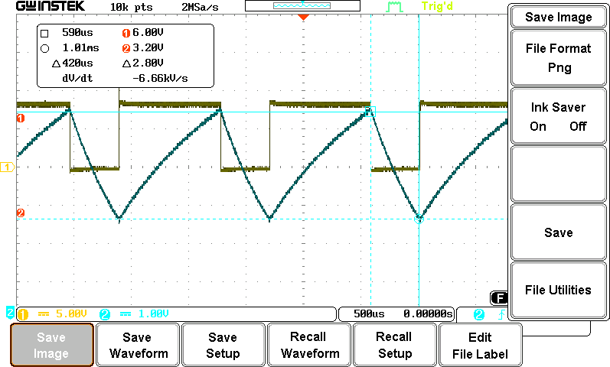

* 1. Output Voltage

|  |  |  |
| --- | --- | --- |
|  | Measured Value | Theoretical Value |
| Capacitance Voltage | +1.72V , -1.78V |  |
| Output Voltage | 9.10V , -8.70V |  |
| High pulse width | 800µs | 938µs |
| Low pulse width | 420µs | 469µs |
| Frequency | 763.052Hz | 705.8Hz |

## Square Wave Generator Applications

1. 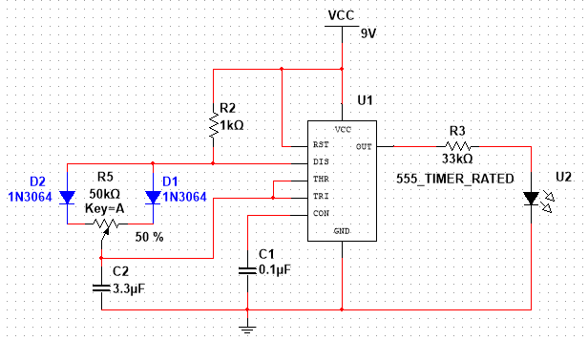Circuit diagram

(2)

(3)

1. Output result
   1. LED off

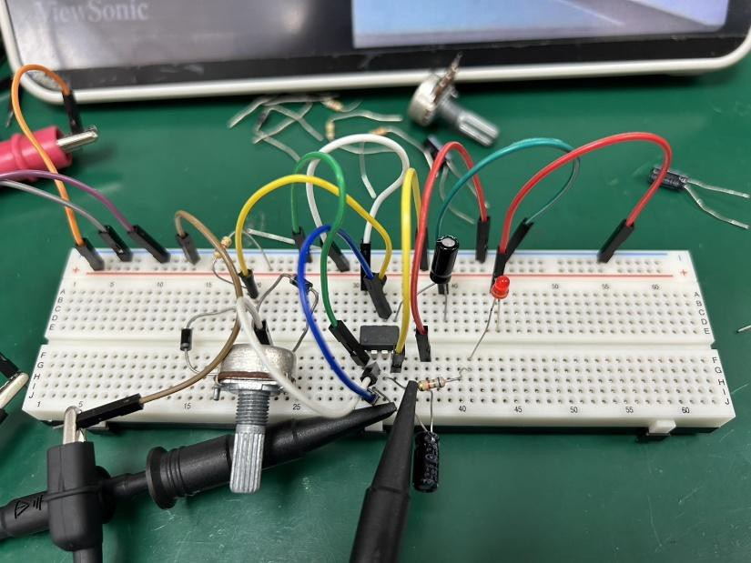

* 1. LED medium brightness

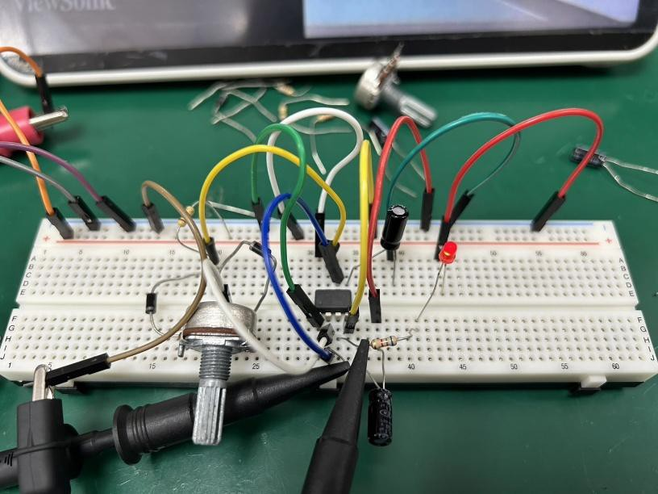

* 1. LED maximum brightness

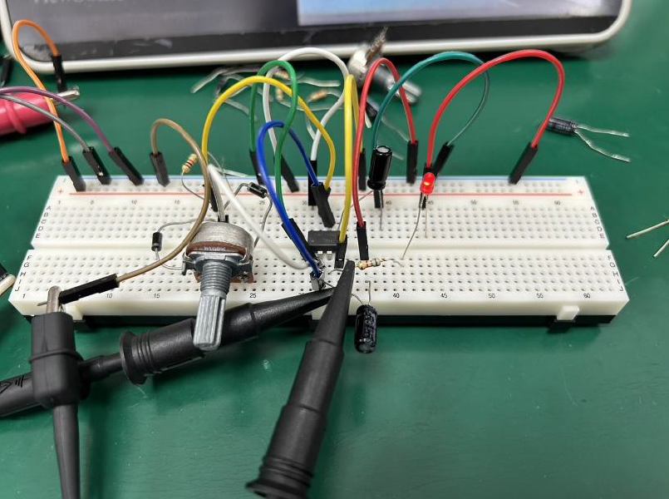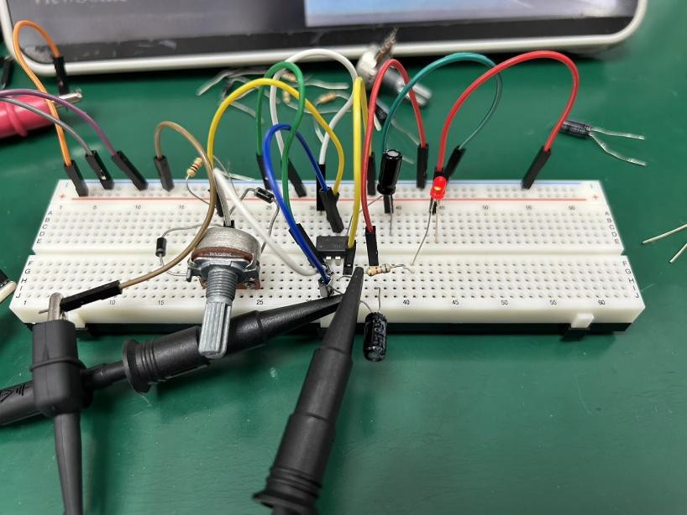

1. Output waveform
   1. LED off

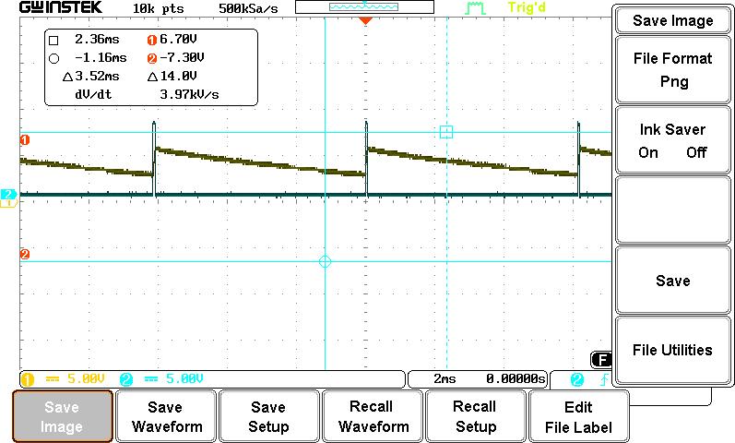

* 1. 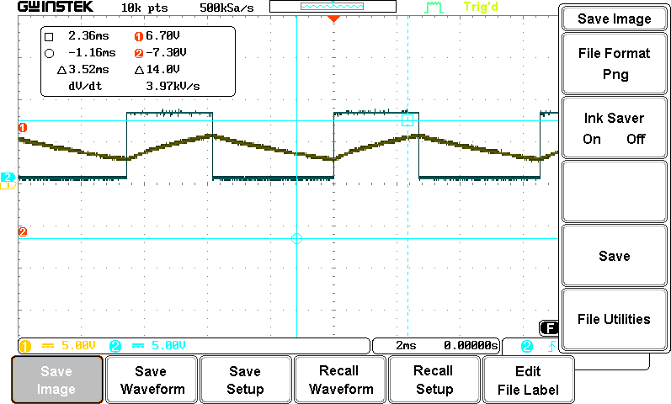LED medium brightness
  2. LED maximum brightness

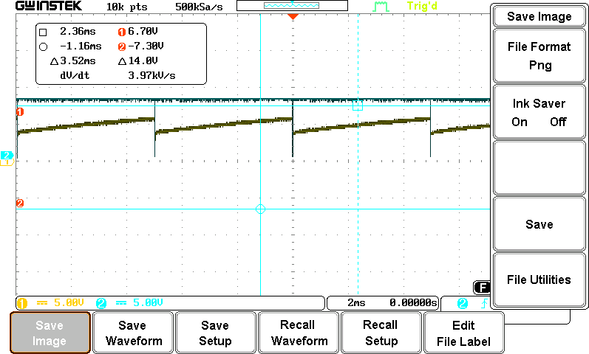

# Reflections

During this lab session, we learned how to construct both monostable and astable circuits using the NE555 timer. Since this is a familiar circuit configuration, we encountered no difficulties in understanding or implementing the designs.

The instructor introduced a new oscilloscope feature - the Single trigger mode - which I had never used before. This function allows the oscilloscope to:

1. Capture and display only the first waveform that meets the trigger conditions
2. Immediately stop acquiring signals after this initial capture
3. Prevent any subsequent trigger signals from being displayed

This feature significantly expanded my understanding of oscilloscope operation. Previously, I typically used either:

* Auto mode: continuously displays any detected waveforms
* Normal mode: captures waveforms only when trigger conditions are met, displaying one complete cycle

The Single trigger mode differs fundamentally by:

* Capturing exclusively the first triggered waveform
* Being particularly valuable for observing transient signals
* Enabling isolation of individual pulses in circuit analysis

This powerful function proves extremely useful for examining transient waveforms, thereby enhancing our understanding of circuit operation principles.